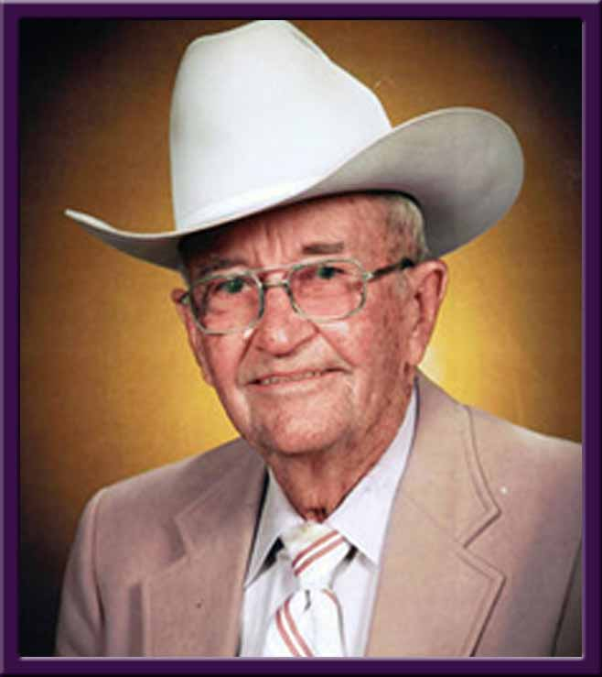
George Asa Jones, 96, of San Angelo passed away Jan. 2, 2016. He was born in San Antonio on Aug. 25, 1919.
He graduated from Texas A&M in 1940 with a Bachelor of Science in agricultural administration. While at A&M, he was a member of the Corp of Cadets and captain of the A&M polo team. He was then commissioned as lieutenant in the U.S. Army Cavalry. During World War II, he served as horse cavalry unit commander in Northern Africa and in central Europe, where he was instrumental in liberating and protecting the Lipizzaner stallions. He earned the rank of major.
Mr. Jones married Nanette Leeman Todd on Feb. 11, 1943 in Fort Riley, KS.
He grew up ranching on the east end of what is today Big Bend National Park and in Arizona on the Double Circles Cattle Co. It has been said “he learned the art of ranching from pioneers who thrived on challenge, with no luxuries and precious few necessities; and he grew into manhood in the wonderful world of the West that made for good story telling.”
Following World War II, he began ranching in Brewster County, Texas. He ranched in West Texas and Missouri until the drought of the ‘50s forced him to take a job in the Peruvian Andes. From there the family went to the Venezuelan jungles near Angel Falls. In 1955 they were able to return to West Texas, where he had a cow-calf operation for 43 years. In the late ‘60s, he expanded to Deming, NM, where he also operated the Deming Livestock Auction. Riding a good horse behind a good cow made him happiest.
Mr. Jones was a member of Texas Farm Bureau, board of directors of Marfa Production Credit Union, Deming Old Timers Association, Texas Southwestern Cattle Raisers, Texas Sheep and Goat Raisers and New Mexico Cattleman’s Association. A member of First United Methodist Church of Deming, his life church was Bloys Camp Meeting in the Davis Mountains, where he served as the president of the Means Evans Camp.
He was preceded in death by his parents, Asa A. and Elsie Elizabeth Jones; wife, Nancy Todd Jones; daughter Deborah Lee Jones; and sister, Helen Stone.
He is survived by Ross D. Jones and wife Marti of Fort Stockton, Texas, and daughter Molly J. Walker and husband John of San Angelo; grandchildren Anna Haney, Ross W. Jones, Amy Wittenbach and William “Matt” Allison; four great-grandchildren; and several nieces and nephews.
Interment of the ashes of George Asa and Nancy Jones will be at 10:30 a.m., Jan. 9, at Eastside Cemetery near Fort Stockton, with a memorial service at 11:30 a.m. at First United Methodist Church, 1600 W. Fifth St., Fort Stockton.
The family thanks Merle Quellar and staff at Bee Hive Homes, Shannon Medical Center and Regency House for their kind and loving care of Mr. Jones. In lieu of flowers, the family request that memorials be made to Bloys Camp Meeting Association, Fort Davis, Texas, or to the Deborah Lee Jones Memorial Library, First United Methodist Church, Fort Stockton.

