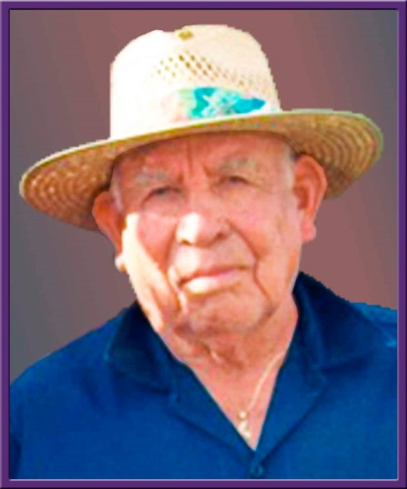
Francisco "Pancho" Luna Leyva
Born October 10, 1922
Died January 8, 2016
At the age of 93
It is with deep sorrow and heavy hearts that we announce the passing of our beloved father, grandfather, uncle, and friend, Francisco “Pancho” Luna Leyva of Las Cruces, NM. Pancho passed away at the age of 93 on Friday, January 8, 2016 at La Posada, Mesilla Valley Hospice surrounded by his loving family.
He was born on Oct 10, 1922 to Amado and Rosa Leyva in Terlingua, Texas. He was the oldest of 12 children. At the age of 13, he quit school and entered the workforce to help support his family. His first job was working in the coal mine. He left the coal mines and took a job at the railroad and also tried his hand as a truck driver, before he found his calling. He entered the construction business as a lather. He worked in construction for 42 years and retired in 1984. He married the love of his life, Flora Alvarado on June 11, 1948 and raised two daughters.
Pancho owned his own farm and had a passion for gardening and raising small farm animals. He was a stranger to none and a friend to all. He was very compassionate and was always willing to help anyone. Pancho loved children and was the ‘’adopted’’ grandpa to many.
He is survived by his daughter Lori Leyva of Las Cruces, a “brother” Ramon Leyba from Midland, Texas, brother-in-law Robert Castillo, from Carlsbad, NM, his devoted nephew Lorenzo Leyba from Roswell NM, grandchildren Veronica Paulin and David Francisco Leyva from Tucson, AZ, seven great grandchildren and numerous nieces and nephews.
He was preceded in death by his wife Flora, daughter Annie Leyva Castillo, and his brothers and sisters.
Visitation : 3:00 PM to 5:00 PM on Tuesday, January 12, 2016 at Denton-Wood Funeral Home.
Vigil at 7:00 PM, Tuesday, January 12, 2016, in the San Jose Catholic Church in Carlsbad, NM.
Mass of Christian Burial will take place Wednesday, January 13, 2016, 1:00 PM at San Jose Catholic Church.
Interment will follow in Santa Catarina Cemetery, Carlsbad, NM. Denton-Wood Funeral Home is in charge of the arrangements.
Casket bearers will be Lorenzo Leyba, Ramon Leyba, Armando Corona II, Michael Meehan, Andrew To, Juan Munoz and Robert Castillo Sr. Honorary casket bearers will be James Connelly and Christopher Hernandez.
Condolences may be expressed at dentonwood.com
Francisco Leyva
Visitation Schedule
Denton Wood Funeral Home
1001 North Canal Street
Carlsbad, NM 88220
Tuesday, January 12, 2016
3:00-5:00pm
Map to Visitation Location
Service Schedule
Vigil
San Jose Catholic Church
1002 South De Baca Street
Carlsbad, NM 88220
Tuesday, January 12, 2016
7:00pm
Map to Service Location
Mass of Christian Burial
San Jose Catholic Church
1002 South De Baca Street
Carlsbad, NM 88220
Wednesday, January 13, 2016
1:00pm
Map to Service Location
Interment
Santa Catarina Cemetery
1506 Boyd Drive
Carlsbad , NM 88220
Map to Interment Location

