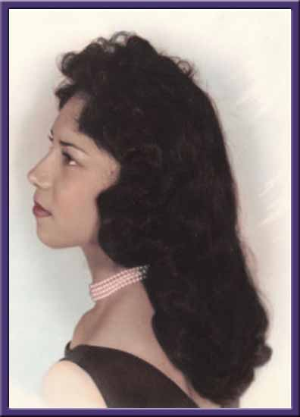

Eva Villalva Chavarria of Fort Stockton passed away Monday July 11, 2016, in Fort Stockton at the age of 77 years. Eva was born on February 10, 1939, to Manuel and Modesta Nava Villalva in Alpine, Texas.

Eva is survived by her husband, Felipe Y. Chavarria;
her sons,
Ruben Chavarria and wife Lisa Chavarria of Fort Stockton,
Armando Chavarria and wife Norma Chavarria of San Antonio,
Orlando Chavarria and wife Catarina Chavarria of Fort Stockton;

her brothers, Adan Rivera, Frank Granado Sr.; her sister, Elizabeth Baiza; her grandchildren, Christopher Chavarria, Kacy Chavarria, Krystal Chavarria, Justyn Arellano; and her great grandchildren, Jordan, Noah, and Jonah Chavarria.
Eva is preceded in death by her parents, Manuel and Modesta Nava Villalva; her son, Benjamin Chavarria; her brothers, Johnny Rivera Sr., Benjamin Villalva, David Villalva; her sisters, Petra Escajeda, Consuelo Rodriguez.
Pallbearers will be: Chris Chavarria, Kacy Chavarria, Justyn Arellano, Orlando Escajeda, Armando Escajeda, and Frank Granado Jr.
Visitation will be on Wednesday, July 13, 2016, from 12-8 p.m. at Heritage Funeral Home in Fort Stockton. Funeral service will begin on Thursday, July 14, 2016, at 10 a.m. at First United Methodist Church in Fort Stockton. Burial will be at East Hill Cemetery in Fort Stockton.

